**Add Text Styling to Blog**

**Send Feedback**

These were a lot of properties to style the text. So, let's apply some to our blog as well.

Below are some of the tasks described in brief -

1. To the anchor tag inside the element with id - 'site-title', remove underline and add line height of '1.25'.

2. To the main title of the blog, set the size of text to '3.2rem'.

3. To all the content of the article, increase text size to '1.1rem', provide '1px' spacing between words and line height of '1.4'.

4. To the unordered list inside the article, add class 'sources'. To the links inside it, remove the underline and change their color to black(provide it in hex code) on hover.

**Expected look of the blog page is -**

[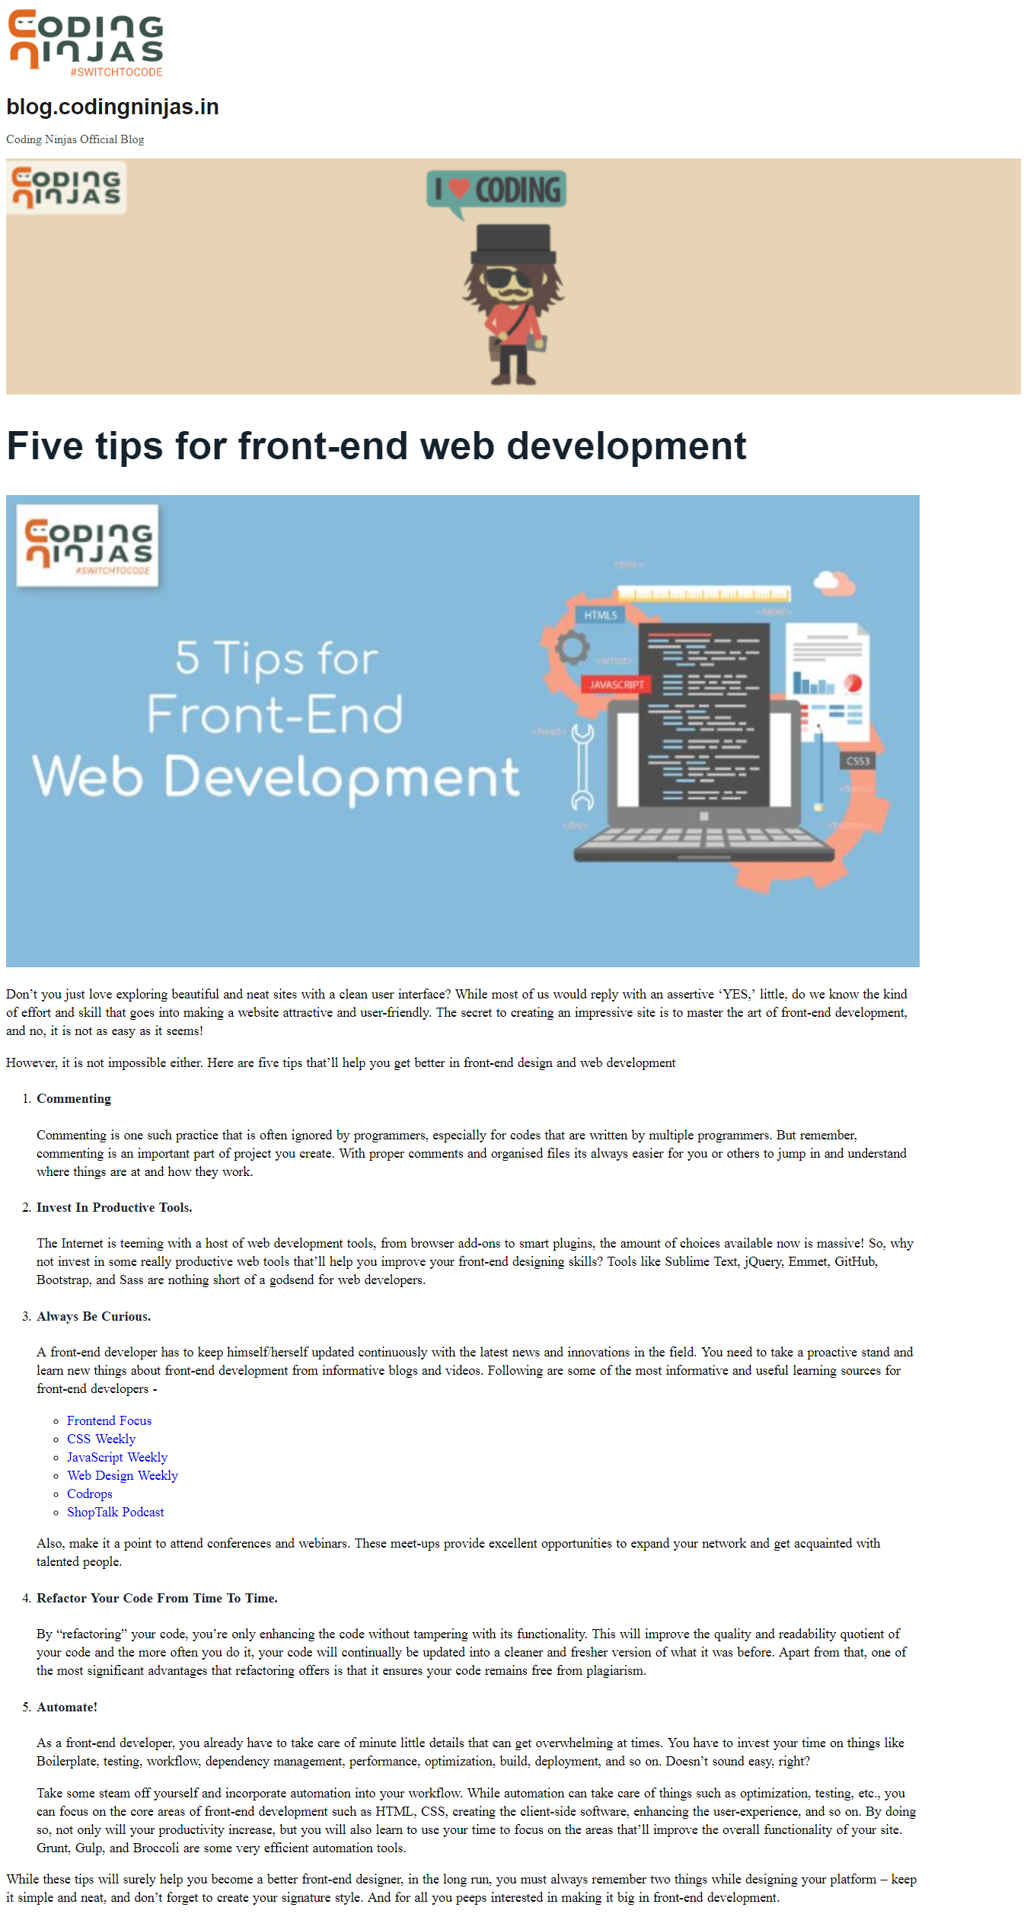](https://ninjasfiles.s3.amazonaws.com/0000000000001566.png)